

REQUEST FOR QUALIFICATIONS:

Design, Engineering, Permitting, Promotion, Monitoring, and Implementation of the

Kansas CPF Broadband Infrastructure Program

for the

Iowa Tribe of Kansas and Nebraska
White Cloud, Kansas
Table of Contents

1. General Information 1
1.1. Request for Qualifications 1
1.2. Project Location 1
1.3. Scope of Services 1
1.3.1. General 1
1.3.2. Services and Deliverables 2
1.4. Cost Savings 4
1.5. Contacts 4
1.6. Selection Process 5
1.6.1. ITKN Rights 5
1.7. SOQ Preparation Instructions 5
1.7.6. Indian Preference 5
1.8. SOQ Content Requirements 6
1.9. Selection Process 7
1.9.6. Selection Criteria 7
1.10. Right of Rejection 8
1.11. Cost of Proposals 8
2. Attachments 9
2.1. Attachment A: Area Map 9
2.2. Attachment B: Fiber Connection Points 10

General Information

Request for Qualifications
The Iowa Tribe of Kansas and Nebraska (“the Tribe”, “ITKN”) requests a statement of qualifications (“SOQ”) from qualified single contractors or teams of coordinated contractors which clearly shows their ability to successfully deliver the services outlined below. Selected contractor (“Contractor”) will work with the Iowa Tribe and its relevant departments to design, engineer, and assist with management of the ITKN’s implementation of its Kansas Capital Projects Fund Broadband Infrastructure Program (“KCPFBIP”, “BIP”) project (“Project”) to accomplish the following:
- Fiber route design, engineering, construction estimating, management, mapping, permitting and pole attachment support, exhibits and submittals, reporting exhibits and as-built support for the middle-mile and last-mile portion of the Project;
- Tower network design, engineering, construction estimation, management, drafting, mapping, permitting support, exhibits and submittals, reporting exhibits, and as-built support for the tower portion of the Project;
- Tower and fiber construction oversight; and,

Submitters will be required to state their understanding of the project and describe past work that exemplifies their ability to complete the project as requested. Further SOQl requirements are included below.

Project Location
    - The project to be completed will connect existing fiber on the Iowa Tribe of Kansas and Nebraska reservation to tribally-owned housing units in the city of White Cloud, Kansas.
    - The Project’s proposed fiber route is attached as Attachment B

Scope of Services

General
      - At a minimum, the initial designs shall be presented to the Iowa Tribe Executive Committee for feedback and comments on three separate occasions: once at an early concept phase, once after sufficient revision following the first presentation, and once at 90% completion of the project scope. CContractor may be required to attend additional meetings, the number of which to be defined by the Owner in collaboration with Contractor through on-going discussion and coordination.

      - Contractor shall perform all work in accordance with all the applicable latest legally enacted editions of tribal, national, state and local codes.

Services and Deliverables
      - Ready for Construction (RFC) drawings for all Project locations and routes. The design and RFC drawings will be of such detail to provide any qualified construction contractor the ability to build the network without additional engineering. We have design objectives that may exceed industry best practices. An outline of the core objectives is included below. Each of the locations and routes listed will receive an in person walk off (site survey) by trained personnel in Outside Plant (OSP) Engineering. This work will be used to determine route viability in conjunction with appropriate location for vaults, pedestals, and smart posts. The information garnered from the walk off will be used to create the ready for construction drawings, create the final bill of materials (BOM), and permit paperwork that is ready for submission. The work will be conducted based on industry engineering best practices. The deliverables of this scope will create a set of construction documents of sufficient detail that the network can be built by any qualified OSP construction contractor. Where applicable, deliverables may include:
        - Ready for Construction Drawings.
        - Bill of Materials (BOM).
        - Permits ready for submission to the appropriate organization.
        - As-Builts which may include but may not be limited to GIS coordinates of Hand holes, Splice Vaults, Pedestals, smart posts, etc.
        - All CAD Data
        - All geo-location data in shape file format.
      - If applicable, provide engineering for the design and development of Network Architecture and Topology ready for construction (RFC) drawings, specifications, and typicals. The Design and installation packages will be of such a detailed nature as to provide any qualified ISP construction contractor the ability to build the physical Core Network without additional engineering. We have design objectives that may exceed industry best practices. Required design objectives include:
        - Design a Fiber network that meets or exceeds industry best practices.
        - The design goal of the network, once built, is that it can be operated with minimally trained personnel.
        - The network design should be based on carrier grade equipment.
        - The Network design should be based on the latest industry security principles.
        - Power sources will be based on: Locally sourced commercial power, DC battery banks, AC inverters, Backup Generators, Alternative Power sources such as Solar, when applicable.
        - All network, power, and environmental equipment should have the ability to be securely accessed and monitored remotely for configuration, provisioning, and alarm status.
        - All power and environmental equipment needs should be calculated to: Accommodate equipment design for initial turn up; Accommodate for future growth; Ensure enough capacity to not over tax power.
        - All Core network equipment capacity must meet the following criteria:
          - Minimum initial offering compliant with Project funder Mbs requirements to each end user.
          - Capacity to meet future proofing with growth in connection rates to end users.
          - All Core network equipment needs to be designed with logical, physical and/ or spare redundancy.
          - Scalable to higher bandwidths to accommodate future proofing.
          - Easily integrate with provisioning interface.
        - Rack space must be sized to accommodate:
Grounding; Power Distribution; Core Network Equipment; Wireless equipment, when applicable; Microwave equipment, when applicable; Middle Mile equipment, when applicable; Fiber Distribution panels and tie feeder panels based on local counts; DNS, firewall, and timing equipment; Keyboard and monitor for local equipment access; Room for growth.
      - Conduct geo-technical analysis and produce a technical report(s) for the specified tower site locations
      - Manage permitting and environmental assessment in collaboration with the ITKN
      - Assist with identifying and procuring necessary Project equipment
      - Collaborate with the ITKN on workforce development aspects of the Project.
      - Among other responsibilities required for the successful development of the required deliverables, Contractor will be responsible for the following:
        - In conjunction with Owner, immediately establish the project requirements, grant deliverables, network design program, prepare a comprehensive list of project tasks, a timeline, and a budget.
        - Design should include written narratives, drawings, and specifications as established and required through ongoing collaboration between the Contractor and the ITKN.
        - Provide rough cost estimates for construction, at a minimum, at the completion of 100% deliverable as specified in the Project requirements.
        - Provide design, engineering, cost estimation, scheduling, and other services required for the successful delivery of a sufficiently developed Project.
        - With the ITKN, co-develop and continue to refine a comprehensive master project schedule and budget. Update and monitor the project schedule and budget with the to identify and plan for deviations and/or changes.
        - Coordinate design tasks with all relevant ITKN staff and Project partners.
        - Coordinate with all relevant regulators to identify regulatory opportunities and challenges that may affect the successful deployment, operation, maintenance, and continuous modernization of the Project.
    - Additional Contractor Obligations and Authorities
      - Contractor will complete all tasks in consultation with the ITKN and all deliverables will require the approval of the ITKN Executive Committee. The ITKN will maintain the right to reject or request revisions to any and all work. Bi-weekly design meetings will be required and will include ITKN, and the Contractor’s representatives, including its project manager, lead design staff, and accounting staff when appropriate.
      - Contractor will provide to ITKN any project records, accounting, and other budgetary documentation and information directly related to the project, in any form, it may request at any time.

Cost Savings
    - To the extent the actual cost of the project may be reduced through the course of the project, the reduction in cost shall revert entirely to the benefit of the ITKN. There shall be no shared savings compensation to Contractor.

Contacts
Please direct all SOQs, questions and other correspondence to:

Jason Pockrus
Grants and Contracts Administrator
Iowa Tribe of Kansas and Nebraska
jpockrus@iowas.org
719-648-3323

Selection Process

ITKN Rights
The Iowa Tribe reserves the right to reject any or all responses to this RFP. Selection of candidates will be based on their apparent ability to best meet the overall expectations of the ITKN and will be determined solely by the Tribe.
The Iowa Tribe reserves the absolute right to conduct investigations as it deems necessary for the evaluation of any SOQ and to establish and check the experience, responsibility, reliability, references, reputation, business ethics, history, qualifications, and financial ability of the submitter. The purpose of such an investigation is to determine that the submitter has the ability, experience, resources, and reputation necessary to perform the work and to support all warranties in accordance with the contract documents.

SOQ Preparation Instructions
    - The ITKN review of qualifications will be based on qualifications of the proposing firms alone. Do not submit fees with your submission.
    - Statements shall not exceed 15 pages in length (with the exception of the Table of Contents, Cover Letter, section dividers, and appendices) and shall be numbered in sequential order. Two-sided, single pages will be counted as two pages.
    - Submittal Requirements: Submit a single PDF file of your SOQ by the submittal date and time included on the RFP posting. Email your submittals to the contact person listed above. All other forms of submission will not be accepted.
    - No proposing firm may submit more than one SOQ. No proposing firm may be part of more than one submitting team. Multiple submissions under different names will not be accepted.
    - Each respondent must comply with the submission requirements as outlined. Submissions that fail to comply with the requirements as specified will be disqualified from consideration. At any stage, the ITKN reserves the right to terminate, suspend, or modify this selection process; reject any or all submittals at any time; and waive any informalities, irregularities, or omissions in submittals, as the best interest of the ITKN may require.

Indian Preference
      - The Tribe will observe the following preferences to the greatest extent feasible:
      - Primary preference will be given to certified “Indian-owned businesses” where the majority owners are Iowa Tribe citizens.
      - Second preference to other certified “Indian-owned businesses”.
      - Third preference to “Major Iowa Tribe member employer” businesses. In no instance shall preference to “Major Iowa Tribe member employer” businesses degrade or supersede preference to Indian-owned businesses.
    - The Contractor will be required to maintain insurance throughout the entire term of the Project, including comprehensive general liability, professional liability, auto liability, workers compensation, and employer’s liability insurance. Contractor will provide the ITKN with a certificate of insurance demonstrating the insurance in effect.

SOQ Content Requirements
    - Table of Contents
    - Cover Letter
Provide a cover letter (maximum length of two pages), indicating the proposer’s interest and summary of qualifications. Include name(s), office location(s), and years in operation for each submitting firm on the submitting team. Include name and contact for the individual authorized to represent the submitter for any correspondence and/or negotiations.
    - Project Understanding and Approach
Summarize the submitting firm’s understanding of the project and the approach it would take toward accomplishing project goals.
    - Experience and Qualifications
Describe the submitting team’s qualifications for completing the project as described and present at least three related design projects completed by the submitting team. Include the below in your project descriptions:
- Project location and dates
- Project costs, including total project costs, construction costs, and submitter’s design fees
- Project intentions
- List of staff directly involved with the project with names and titles
- Client/Owner contact with telephone number
- Owner’s Representative (if any) contact with telephone number
    - Appendices: Project Team & Staff (not included in page count)
      - Please provide resumes (maximum two pages each) for the key members of your team
      - Please provide references for your team’s project manager and lead designer (including telephone numbers and email). Clearly identify which project and who the reference is in relation to.
      - Provide an organizational chart graphically indicating how the submitter would staff and structure its proposed team.

Selection Process
    - The ITKN will review all responses to this RFP that meet requirements and are received prior to the designated closing date and time.
    - Upon review of the qualified firms, the Tribe will select the proposal which best reflects the Tribe’s needs and requirements.
    - The top submitter’s proposal, based on qualifications, will be provisionally accepted and negotiations will commence.
    - If a satisfactory agreement with the proposer cannot be reached, at a price that is determined to be fair and reasonable, negotiations with that firm shall be formally terminated. Negotiations with the second ranked proposer may then be initiated. Failing accord with the second ranked proposer, Owner shall formally terminate negotiations and may then undertake negotiations with the third ranked proposer, or re-issue the RFP, at its discretion.
    - The ITKN will have sole determination of which proposal is in its best interest.

Selection Criteria
      - The following items will be reviewed to provide a basis for selection, they are not in priority order, Applicants with a score of at least 70 will be considered minimally qualified:
1) Statement (30 Points) of submitter’s qualifications, including related experience with similar types of projects. Submitters with experience designing middle-mile and last mile fiber projects and tower projects. Familiarity with designing projects in terrain similar to that of the Iowa Tribe Reservation, a history of working with tribal regulators, state regulators and federal regulators and familiarity working directly with Tribal governments.
2) Qualifications (25 Points) and experience of key individuals, who will be assigned to this project, as indicated by prior involvement in similar projects. Same preferences as described in the Statement Section apply.
3) Three project references (15 points) with project contact names and telephone numbers, and brief project descriptions. We are looking for a record of innovation, integrity, judgment, performance, and timeliness in the execution of previous contracts. Same preferences as described in the Statement Section apply.
4) Evidence of Indian ownership (10 points) or other Indian Preference.
5) Proposed approach (20 points) to completion of the scope of work and understanding of the project and project issues.

Right of Rejection
    - The ITKN reserves the right to accept or reject any or all responses to this RFP and to enter into discussions and/or negotiations with one or more qualified proposing firms, if such action is in the best interest of the Tribe. The ITKN has the right, in its sole discretion, to select the qualifying proposal or proposals that the Tribe determines best meets its needs.

Cost of Proposals
    - Expenses incurred in the preparation of proposals in response to this RFP are the Proposing Firm’s sole responsibility. The ITKN assumes no responsibility for payment of any expenses incurred by any proposing form as part of the RFP process.

Attachments

Attachment A: Area Map

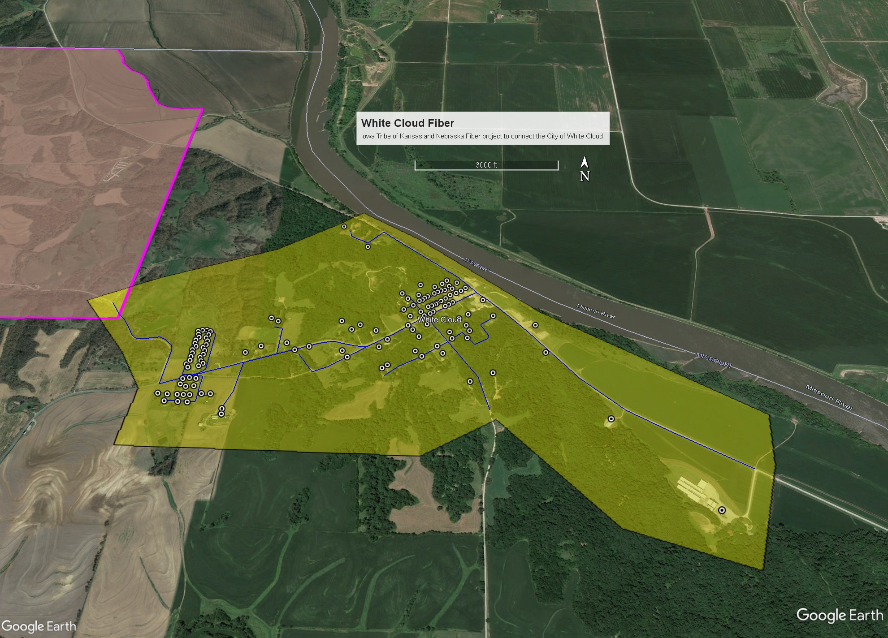

Attachment B: Fiber Connection Points

