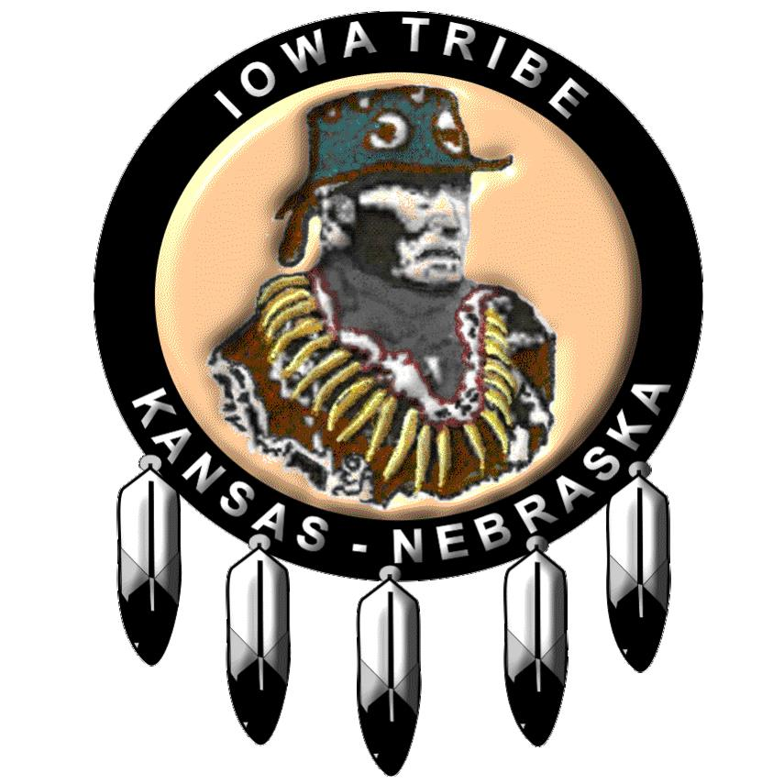

I,____________________(print name), give the Iowa Tribe of KS & NE and/or Grey Snow Management Solutions permission to run a background check, a Motor Vehicle Report, and call any references provided for employment and/or Board appointment purposes. I understand that my employment offer, appointment, or agreement may be revoked or terminated based on report findings.

Full Legal Name:

Any other last names used:

Date of Birth:

Birth City/State:

Social Security number:

Current address **including** County:

Driver’s License #

State Licensed In:

Email Address:

Telephone:

Sign:________________________Date:________________